**WEB PROGRAMMING:**

**HTML INTRODUCTION:**

**TASK_1**

**CODE:**

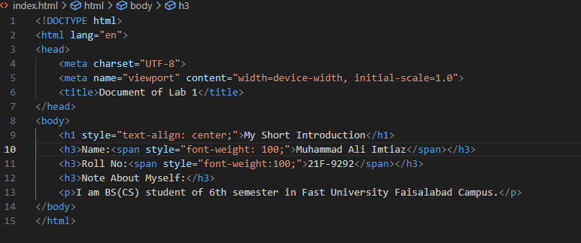

**OUTPUT:**

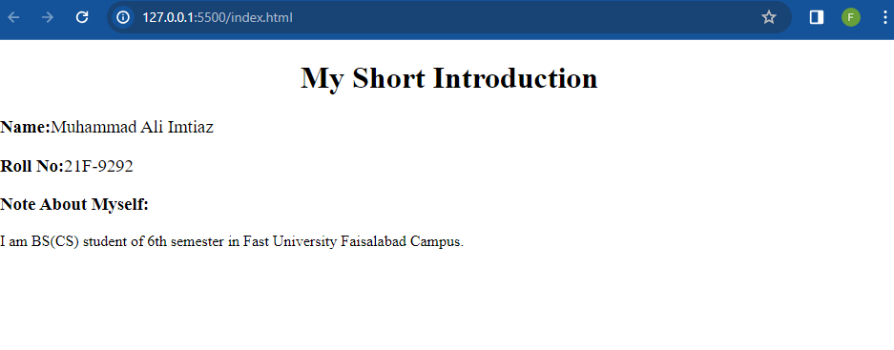

**TASK_2**

**CODE:**

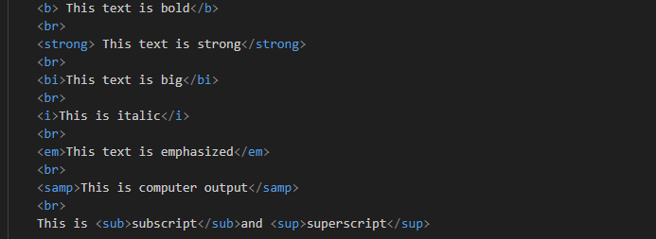

**OUTPUT:**

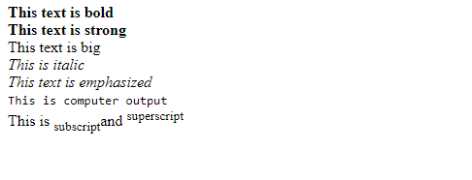

**TASK_3**

**CODE:**

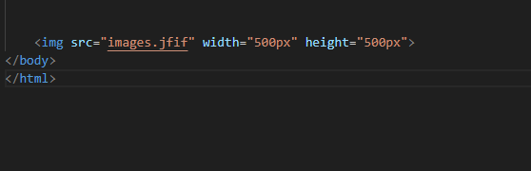

**OUTPUT:**



**TASK_4**

**CODE:**



**OUTPUT:**



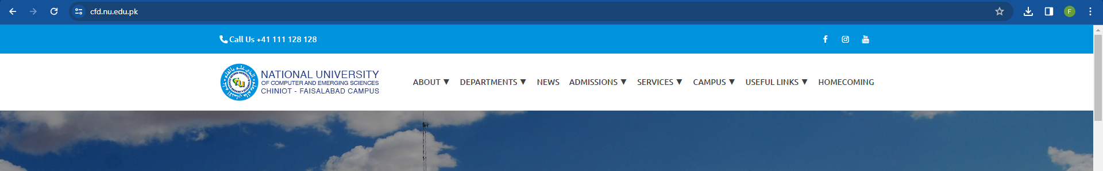

**Task_5**

**Code:**

**Output:**

**Task_8:**

**Code:**

**Output:**

**Task_9**

**Code:**

**Output:**

